**Practical 3**

|  |  |
| --- | --- |
| Roll No. A016 | Name: Varun Khadayate |
| Program: B-Tech (CSBS) | Division: SY |
| Batch: 1 | Date of Experiment: 30-1-2021 |
| Date of Submission: 01-02-2021 | Grade: |

**Relationship between Student, Professor and Employee of the company**

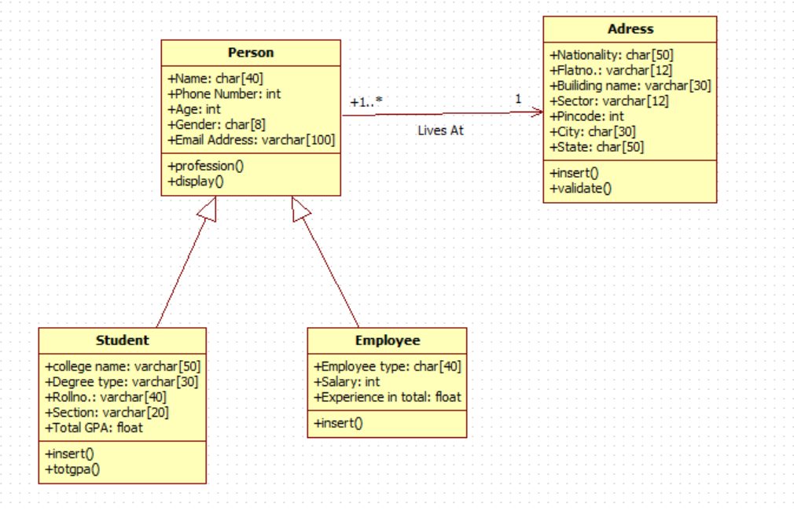

**Customer Order & Payment**

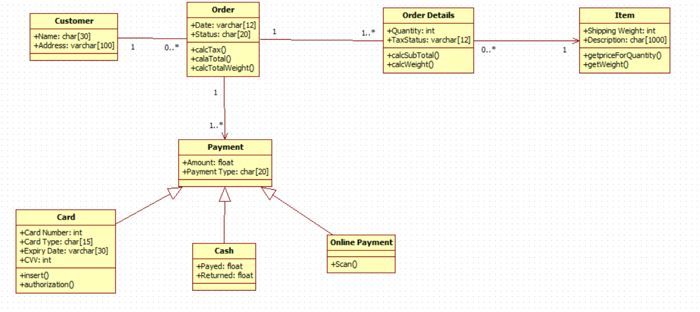

Use Case description / Flow of Events:

Person, Student and Employee

1. A person contains all the details that are necessary for any individual like name, email id, phone number, etc.
2. A university student has all the information that he/she should know like his/her CGPA in the semesters completed, course studying, program enrolled in, roll number, etc and also has information which every person knows like address, name, etc.
3. A university professor has the information like hours taught, salary, subject he/she is teaching, date hired, etc.
4. An employee has information like what role he/she plays in the university, his department, salary, date he/she was hired,etc.

Customer Order and Payment (online system)

1. The customer creates an account on the shopping website or logs in into his/her existing account.
2. When the customer logs into the account, his account status is set as Active or NEW if a new account is created. (before: inactive)
3. The customer adds the items in the cart that are required by him/her.
4. The customer wants to purchase a mobile phone, so he/she enters the name of the brand and model name in the search row.
5. He checks the list of products and adds the one in the cart which he is comfortable with in terms of the price, size, etc.
6. The customer places the order by filling the details like the address where it must be delivered, mobile number, etc.
7. The customer in end pays for the order and exits the website by logging out of the website.
8. The administrator keeps the record of all the activity done by the customer and provides a date of arrival and date on which the order placed to the customer in the order summary before the customer logs out.
9. The order handler fills all the details like order shipped, order status, etc and provides the order status to the customer when he/ she logs into the account.